Colyton Grammar School Buzzer System

Usage Instructions & Documentation

# Chapter 1: The Buzzers

## Required Parts

Fairly simplistic in terms of construction, a single buzzer only requires 8 parts. These parts can be separated into two sections: purchasable, and self-manufacture.

Alongside the parts, reasonable soldering skill (and access to solder and a soldering iron) is required. Wire strippers / cutters and a hot glue gun will also be required.

### Purchasable Parts

The following table contains a list of the parts that will need to be procured to build one buzzer. Only one of each of the parts is required.

|  |  |  |  |  |
| --- | --- | --- | --- | --- |
| **Item Description** | **Cost per Pack** | **Units per Pack** | **Vendor** | **Purchase Link** |
| 2x AAA Open Battery Holder | £1.50 | 1 | The PiHut | <https://thepihut.com/products/2-x-aaa-open-battery-holder-with-jst-ph-connector> |
| 7 Bit WS2812 NeoPixel LED | £10.59 | 10 | Amazon - Yosoo | <https://amzn.eu/d/3NLNt4Y> |
| 12mm Momentary Push Button | £6.99 | 24 | Amazon - Gebildet | <https://amzn.eu/d/8OobuOT> |
| Edge Connector Breakout Board for micro:bit | £5.10 | 1 | The PiHut | <https://thepihut.com/products/edge-connector-breakout-board-for-bbc-micro-bit-pre-built> |
| BBC micro:bit V2 | £16.50 | 1 | Pimoroni | <https://shop.pimoroni.com/products/new-micro-bit-v2?variant=32271548481619> |

In addition to the parts listed above, at least 5 wires (with one end terminated with a Dupont female connector) will be required during the assembly stage.

To use the buzzers, an extra micro:bit (the same as the one listed in the table) – only 1 – will need to be purchased.

### Self-Manufactured Parts

The following parts will need to be 3D printed. The required STL files can be found in the ‘Design Files’ directory.

|  |  |  |  |
| --- | --- | --- | --- |
| **Item Description** | **Quantity Required** | **Recommended Colour** | **File Name** |
| Main Plate | 1 | Black | Plate.stl |
| Leg Brace | 1 | Black | Brace.stl |
| Leg | 4 | Black | Leg.stl |
| Breakout Holder - LEFT | 1 | Black | BreakoutHolderL.stl |
| Breakout Holder - RIGHT | 1 | Black | BreakoutHolderR.stl |
| LED Light Diffuser | 1 | Transparent | Diffuser.stl |

Once all the parts have been gathered, assembly of the buzzer can begin.

## Assembly

### THIS SECTION IS UNFINISHED ###

## Setup

Before being used for an event, the appropriate firmware must be installed (or flashed) onto the micro:bits.

A tool is provided within the software bundle to make this process easier.

1. Navigate to the ‘Microbit Setup’ directory and open the ‘Microbit Setup Wizard’ application.

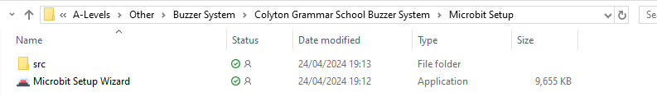

1. 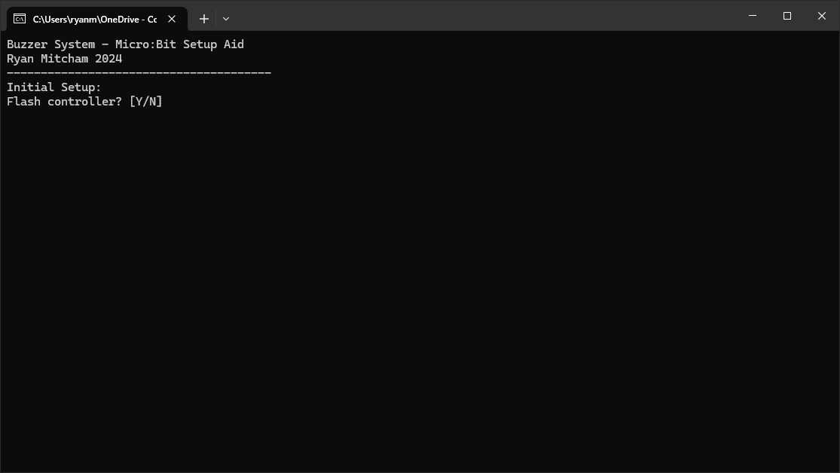A console window like the image below should appear.
2. Determine whether a controller micro:bit should be flashed. The controller is required for any buzzer setup, so if no micro:bit has already been setup with the controller firmware, enter ‘Y’. If a controller micro:bit has already been setup, then it is fine to enter ‘N’.
3. The next prompt to appear will ask whether to flash a host buzzer. The host buzzer is essentially a control option – it allows the host to buzz and select the team they wish to represent. This is useful to highlight a specific team, without asking a member of the team to buzz. The host buzzer is not required during an event. Therefore, it comes down to the personal preference of the host as to whether one is used.
4. Enter the starting index of the buzzers to be flashed. In most cases, this will be ‘0’, unless some micro:bits have been flashed separately. In this case, simply use 1 + the highest flashed index as the start.
5. Enter the last index of the buzzers to be flashed. Simply add the number of micro:bits to flash to the starting index. This number is inclusive, and the maximum value is ‘15’.
6. The flashing process is then ready to begin. When prompted, connect a micro:bit to the computer, and wait for it to be detected.
7. Press ‘*ENTER*’ and wait for the flash operation to complete.
8. Disconnect the micro:bit. If it is not a controller, insert it into the buzzer, by slotting it into the breakout board (LED matrix and buttons facing upwards). Also, connect the power by plugging the JST connector from the battery pack into the port on the back of the micro:bit (before attempting to configure the buzzers using the control app, ensure they are all powered on correctly) – the buzzer LED should turn orange (or green in the case of the host buzzer).
9. Repeat steps 7-9 when prompted.
10. Once all the micro:bits have been flashed, the program will exit automatically.

# Chapter 2: The Control App

The control app runs on a Windows device, connects to the controller micro:bit via USB connection, and is the only way to setup teams and interface with the buzzers for an event.

It is recommended to read through this chapter thoroughly before taking on the technical host role of an event. There is also some required knowledge before attempting to learn the interface.

**IMPORTANT:** The Control App will only open when the controller micro:bit is connected. Ensure that the controller micro:bit has been flashed and is plugged in before starting the app.

## Required Knowledge

When powered on and setup, the buzzers can be in one of four states.

1. Inactive – the buzzer is not waiting for a press. If the button is pressed while the buzzer is in this state, nothing will happen. This is the default state when not setup.
2. Waiting – the buzzer is waiting to be pressed. If the button is pressed while the buzzer is in this state, a signal will be sent to the controller micro:bit and the control app will play a sound effect and display the name of the buzzer pressed; all the other buzzers will then be placed in the inactive state.
3. Active – the buzzer has been pressed (or identified) and is being highlighted.
4. Locked – the buzzer has been locked out by the host (for example, as a penalty for answering a question incorrectly). The buzzers that are not locked will then be in the waiting state. Nothing will occur if the button of a locked buzzer is pressed. The lock on a buzzer is persistent – unless the host actively removes it (or moves to the next question), the buzzer will remain locked.

The colours displayed by the LED in each of these states can be changed, by setting a team colour palette.

## The Interface

The interface is designed to be intuitive and easy to use when running an event.

All functions are organised into clearly named tabs, and some widgets can be ‘popped-out’ and used in a different window from the main app – which can be useful if using a multi-monitor setup.

To switch tabs, click the corresponding name in the select bar at the top of the interface.

A breakdown of all the tabs can be found below.

### Hosting Tab

The Hosting tab is the page that appears when the app is first opened. It contains all the controls to open and lock the buzzers. In addition, this tab contains information about the current question.

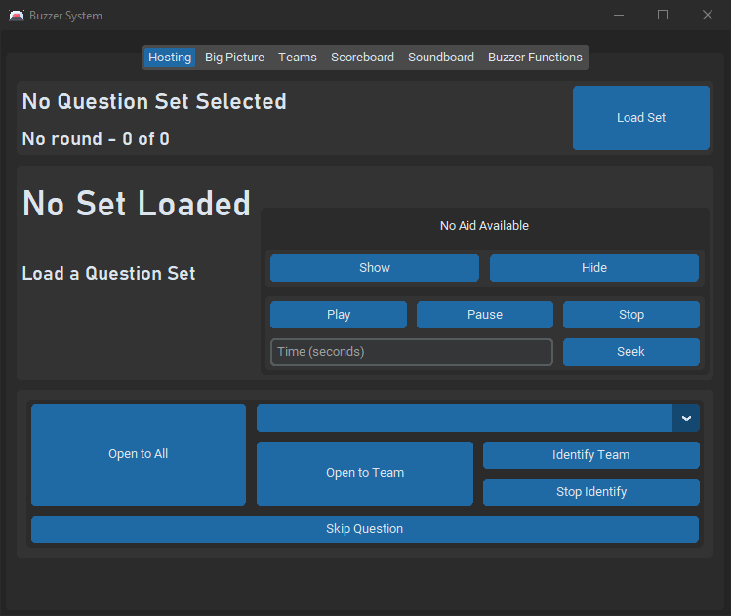

This frame displays information about the current question set. The ‘*Load Set*’ button allows a question set to be loaded from the database.

Information about the current question is displayed. The question, answer, points available, and any relevant notes are displayed here. Additionally, the Question Aid Control frame is visible in the bottom right of the frame. If the question has an aid (image, audio, or video) assigned to it, its playback is controlled here. The aid will appear on the Question screen of the Big Picture Display.

This is the Buzzer Control Frame. All the buttons to open, close, and lock the buzzers, as well as controlling the automatic scoring are found here.

The Buzzer Control Frame can contain different buttons depending on the states of the buzzers and question display. These options are explained below.

#### Question Start/Closed

If the buzzer entry is closed and no one has buzzed, the following options will appear.

**Open to All** – set all unlocked buzzers to the waiting state. Once pressed, the Buzzer Control Frame will move to the ‘*Waiting for Press*’ state.

**Open to Team** – set only the buzzers assigned to the team highlighted in the select box above to the waiting state. Buzzers that are not assigned to the selected team will be set as inactive. Once pressed, the Buzzer Control Frame will move to the ‘*Waiting for Press*’ state.

**Identify Team** – set only the buzzers assigned to the team highlighted in the select box above to the active state – simulating a press by one of the team members. Buzzers that are not assigned to the selected team will be set as inactive. Once pressed, the Buzzer Control Frame will move to the ‘*Buzzed*’ state.

**Stop Identify** – set all buzzers to the inactive state. Pressing this button does not affect the state of the Buzzer Control Frame.

**Skip Question** – move to the advance phase of the question. This means all the buzzers will become inactive, and their locks will be reset. The current question information will continue displaying, allowing the host to share relevant information or notes. Once pressed, the Buzzer Control Frame will move to the ‘*Advance Question*’ state.

#### Waiting for Press

The Buzzer Control Frame will display the following options if at least one buzzer is in the waiting state and is ready to accept a press.

**Buzz as Team** – allows the host to buzz as if they were a member of any team. When pressed, a selection box will open prompting the user to select a team. Once selected, the buzzer sound effect will play, and the Buzzer Control Frame will move to the ‘*Buzzed*’ state. The alias and team will be “[selected team] - Host”. All buzzers will be set as inactive.

**Skip Question** – move to the advance phase of the question. This means all the buzzers will become inactive, and their locks will be reset. The current question information will continue displaying, allowing the host to share relevant information or notes. Once pressed, the Buzzer Control Frame will move to the ‘*Advance Question*’ state.

**Close Entry** – sets all buzzers to the inactive state. As no buzzers will be waiting for press, the Buzzer Control Frame will switch back to the ‘*Question Start/Closed*’ state.

If the controller micro:bit receives a signal that one of the buzzers has been pressed in this state, the Buzzer Control Frame will switch to the ‘*Buzzed*’ state – the buzzer sound effect will also be played.

#### Buzzed

The Buzzer Control Frame will display the following options if a team has been identified or a buzzed signal has been received.

The text will display the team and alias of the buzzer that was pressed.

**Reopen to All** – put all unlocked buzzers into the waiting state. Do not lock any buzzers that were not already locked. Once pressed, the Buzzer Control Frame will move to the ‘*Waiting for Press*’ state.

**Reopen – Lock Individual** – set the individual buzzer that buzzed to the locked state and set all other unlocked buzzers to the waiting state. Once pressed, the Buzzer Control Frame will move to the ‘*Waiting for Press*’ state. The incorrect sound effect will be played.

**Reopen – Lock Team** – set any buzzers in the same team as the one that buzzed to the locked state and set all other unlocked buzzers to the waiting state. Once pressed, the Buzzer Control Frame will move to the ‘*Waiting for Press*’ state. The incorrect sound effect will be played.

**Reset** – remove the lock on all the buzzers. Once pressed, the Buzzer Control Frame will move to the ‘*Question Start/Closed*’ state.

**Correct** – indicate that buzzed player has answered the question correctly, and the host wishes to advance. If a question set is loaded, the bonus points will be automatically applied to their score and the correct sound effect will be played. Once pressed, the Buzzer Control Frame will move to the ‘*Advance Question*’ state.

**Skip Question** - move to the advance phase of the question. This means all the buzzers will become inactive, and their locks will be reset. The current question information will continue displaying, allowing the host to share relevant information or notes. Once pressed, the Buzzer Control Frame will move to the ‘*Advance Question*’ state. Pressing this will have no effect on the scores.

**Incorrect** – indicate that the buzzed player has answered the question incorrectly, but the host wishes to advance. If a question set is loaded, the penalty will be automatically deducted from their score and the incorrect sound effect will be played. Once pressed, the Buzzer Control Frame will move to the ‘*Advance Question*’ state.

#### Advance Question

When the host has indicated they are ready to move to the next question, the ‘*Advance Question*’ options are displayed.

If no question set is loaded, the Buzzer Control Frame will automatically switch back to the ‘*Question Start/Closed*’ state, as the question cannot be advanced if no set is loaded.

When this state is loaded, the locks on all the buzzers are reset. The current question information continues to display, giving the host time to add some relevant information.

**Next Question** – load the next question. If the end of the round has been reached, the ‘*Advance Round*’ options will be displayed. Otherwise, the next question will be displayed and the ‘*Question Start/Closed*’ state is set on the Buzzer Control Frame.

#### Advance Round

**Next Round** – indicates the host is ready to move on to the next round. The question will be loaded, and the first displayed. Once pressed, the Buzzer Control Frame will move to the ‘*Question Start/Closed*’ state.

**Skip Round** – move to the round after the next. Once pressed, the Buzzer Control Frame will move to the ‘*Question Start/Closed*’ state (the first question of that round will be loaded).

**Restart Set** – move back to the first round. Once pressed, the Buzzer Control Frame will move to the ‘*Advance Question*’ state (pressing ‘**Next Question**’ will start the set).

**Jump to Round** – this button will display a selector prompting the host to select the round to jump to. Once chosen, the selected round will be loaded, and the first question displayed. Once pressed, the Buzzer Control Frame will move to the ‘*Question Start/Closed*’ state.

### Big Picture Configuration Tab

The Big Picture Configuration tab (named within the interface as ‘Big Picture’) contains all the options to configure the audience display.

This tab allows the host to select what screen (as detailed in the section dedicated to the Big Picture Display later) to display to the audience, as well as configure automatic transitions – such as switching to the round title screen when the next round starts.

For a breakdown of the configuration settings at the bottom of the tab, see the section of the chapter dedicated to the Big Picture Display.

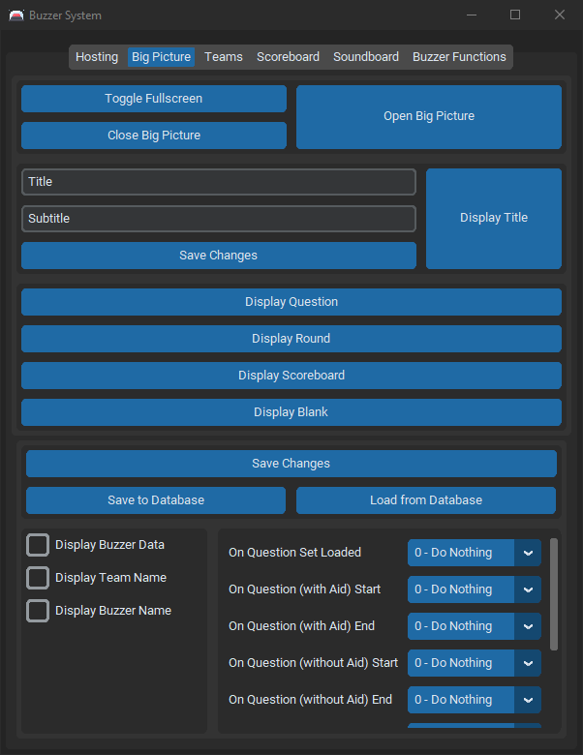

These buttons allow the host to open, close, and full screen the Big Picture Display.

This frame allows the host to set an event title and display it on the Big Picture Display. When loaded, a question set may overwrite this.

These buttons allow the host to set what is displaying on the Big Picture Display – more information can be found below.

These settings allow fine control over the Big Picture Display – such as setting automatic cues. A breakdown of these can be found below. The ‘*Save to Database*’ and ‘*Load from Database*’ buttons can be used to store configurations between events.

### Team Setup Tab

The Team Setup tab (shortened within the interface as ‘*Teams*’) allows the buzzers to be assigned to a team with colour palette and given an alias. This tab also allows buzzers to be identified as a whole set or individually – they can also be identified by team, but that option is found within the Hosting tab.

**CGS Specific Feature – Naming a team with one of the houses (‘Ash’, ‘Beech’, ‘Cedar’, ‘Oak’, or ‘Elm’) will automatically load the relevant colour palette when the ‘*Save Teams*’ button is pressed.**

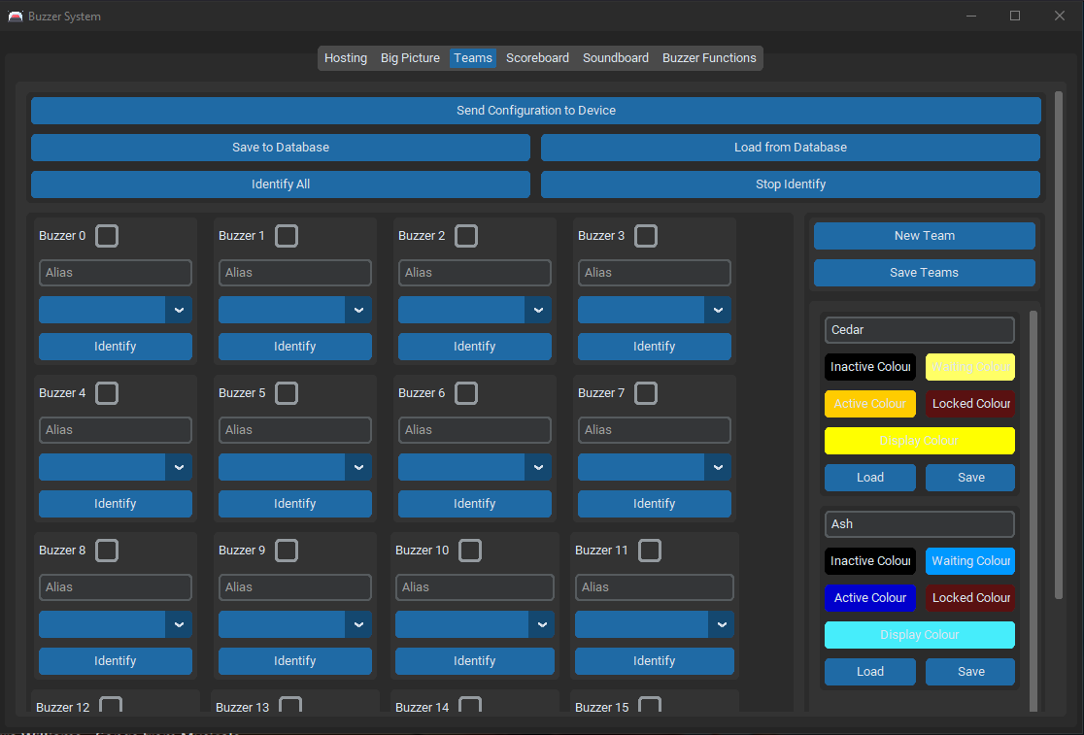

Sends the configuration to the controller micro:bit which passes it on to the buzzers. As the teams get reset, all scores will be set to 0.

Allows team configurations to be saved to and loaded from the database, to make setting up an event easier.

Allows all the buzzers to be identified (set active) or set inactive (stop identify).

Each buzzer has a section to configure them. The checkbox sets whether the buzzer should be considered ‘in use’; the alias text entry allows the host to enter the name of the person using the buzzer; and the dropdown allows the team to be selected. The ‘*Identify*’ button sets that buzzer active, and all others inactive.

Each team has a configuration frame. It allows the name and colour palette of the team to be set. A colour palette can be loaded from or saved to the database using the ‘*Load*’ or ‘*Save*’ button or configured manually using the other buttons in the frame. Team names must be unique and cannot be empty strings.

The ‘*New Team*’ button creates a new team configuration frame. The ‘*Save Teams*’ button updates the team dropdown of the buzzer configurations.

### Scoreboard Tab

Once teams have been setup (using the Team Setup tab), their scores will appear in the Scoreboard tab. The host can manually add or remove points from individual teams. There is also a shortcut button to display the scoreboard on the Big Picture Display.

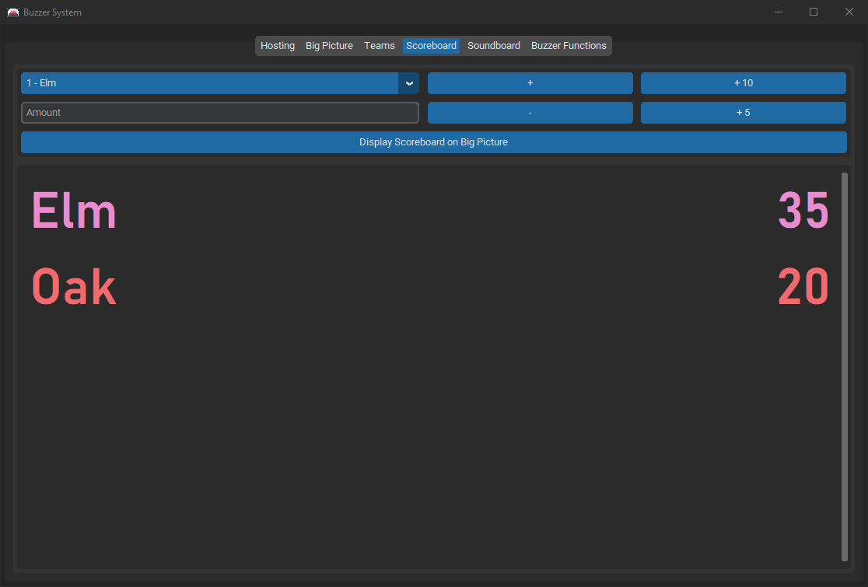

This area displays each team and their score in order of highest to lowest.

A shortcut to display the scoreboard on the Big Picture Display.

Allows the host to manually adjust the scores on a team-by-team basis.

### Soundboard Tab

Possibly the simplest section of the interface, the Soundboard tab simply presents a list of buttons that will play the sound effect described on it.

The large button at the top labelled ‘Stop all Sounds’ will silence the audio mixer and kill all output channels.

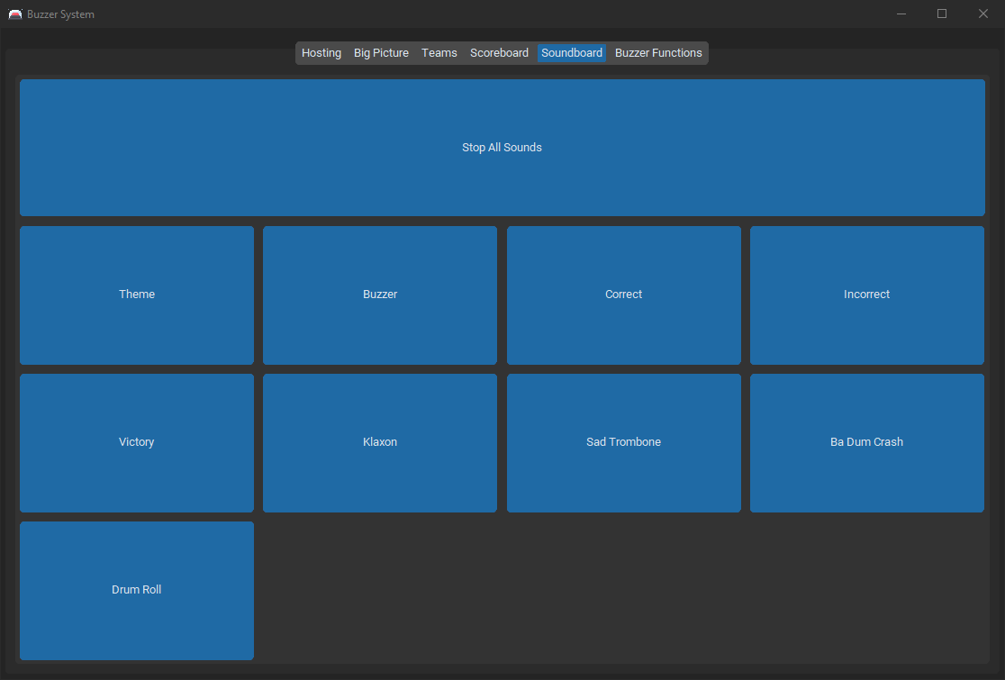IMPORTANT: Pressing the ‘**m**’ key will silence the output of any sound effect – automatic or user-initiated – until the key is released.

### Buzzer Functions Tab

The Buzzer Functions tab contains all the functions that don’t fit into any other section.

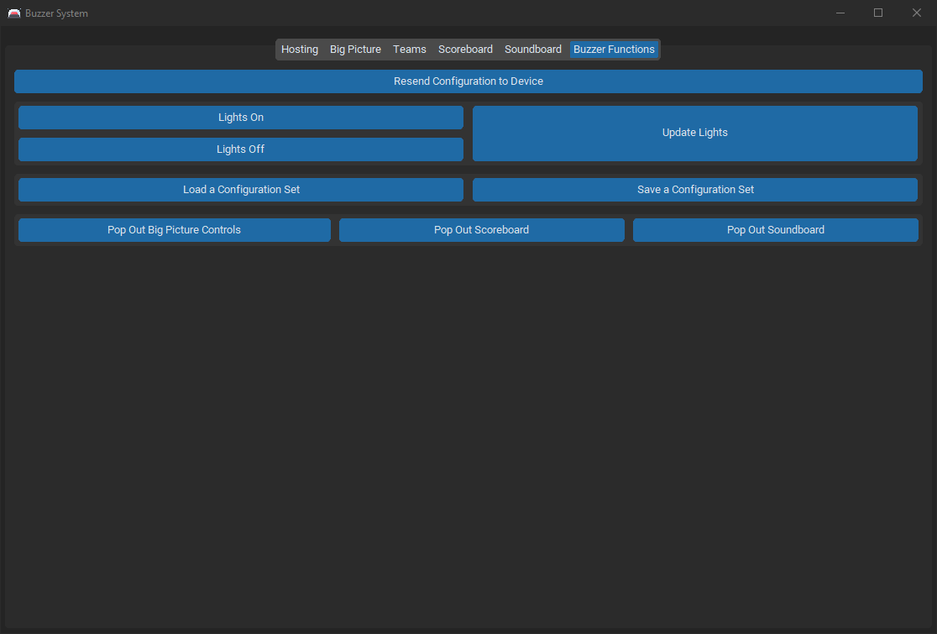**Resend Configuration to Device** – if another buzzer is added, and the configuration doesn’t need to be changed to support it, this button can be pressed which will update that buzzer’s configuration without resetting the scores to 0.

**Lights On/Off** – set whether the buzzers should display their LED. If the lights are set to off, the buzzers will work as normal (just with no LED status display).

**Update Lights** – update the state of all the buzzers. This can be useful if a lost update occurs.

#### Configuration Sets

Configuration sets are used to help streamline event setup. They allow the host to load a Question Set, Big Picture Configuration, and Team Configuration simultaneously. Unless any specific changes need to be made, the only thing the host would need to do after loading a configuration set is press ‘**Send Configuration to Device**’ in the Team Setup tab (to pass the Team Configuration to the buzzers).

**Load a Configuration Set** – display a selector, which can be used to decide which configuration set to load.

**Save a Configuration Set –** display a multi-selector, where a name can be inputted, along with selections for the Question Set, Big Picture Configuration, and Team Configuration to link.

#### Pop-Out Widgets

There are three widgets that can be popped out (i.e. separated into a different window):

* **Big Picture Controls** – to grant the host fast access to change the audience’s view of the event.
* **Scoreboard** – so the host can always see the current scores (and possibly make comments on them) without switching from the Hosting tab.
* **Soundboard** – to grant the host fast access to the soundboard, to respond quickly to comments with a sound effect.

The three ‘**Pop Out [widget name]**’ buttons at the bottom of this tab can be used to pop out the widgets. To put the widget back into the main window, simply close the pop-out window.

## The Big Picture Display

The Big Picture Display is a way for the host to communicate information to the audience. Usually displayed on a projector screen or other large screen visible to all, the Big Picture Display allows the current question, round, scoreboard, or event title to be shared with the audience.

There can only be one instance of the Big Picture Display open at any one time. To open, click ‘*Open Big Picture*’ in the Big Picture Configuration tab. When the window opens, drag it to the correct monitor and press ‘*Toggle Fullscreen*’.

### Available Displays

In its default state, the Big Picture Display shows a plain black screen. Other views that can be switched to (either manually via the Big Picture Configuration tab; or automatically using cues) can be found below.

#### Title Display

This display simply displays the title and subtitle set in the Big Picture Configuration tab.

Some question sets, when loaded, may set the title themselves – so it’s best to ensure everything is correct before starting an event.

#### Question Display

There are two forms of question display on the Big Picture Display – with aid or without aid.

If the question aid is set to be shown (using the Question Aid Control Frame on the Hosting tab), the question will be pushed towards the top of the display, and the aid (if any exists) will be shown below.

If the question aid is hidden, the question will be centred.

The example image below, shows the question display with the aid hidden.

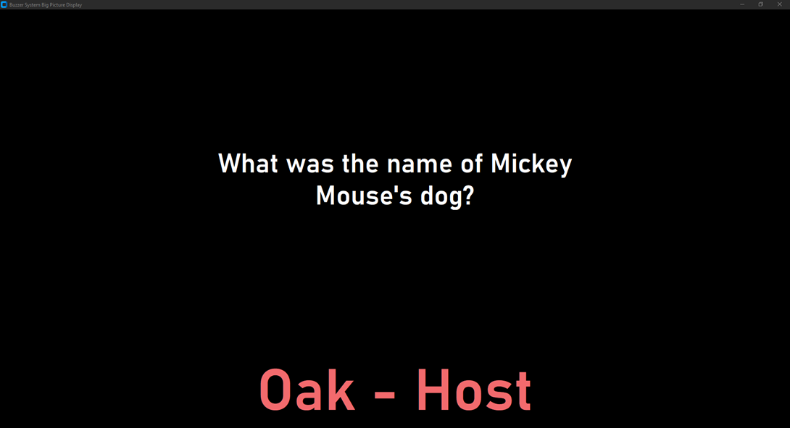

This image also demonstrates the text that appears whenever someone buzzes (if enabled in the Big Picture Configuration settings). This text is not limited to the question display, and will appear whenever anyone buzzes, regardless of the current display.

#### Round Display

The round display shows the ‘*Display Name*’ of the current round along with a counter (of round number).

#### Scoreboard Display

The scoreboard displays a list of the current teams and their scores (ordered from highest to lowest). The text colour that each team’s segment will appear in can be changed by adjusting the ‘*Display Colour*’ of the team’s colour palette.

#### Blank Display

The blank display is simply a black screen – no information will be shown.

### Configuration Breakdown

This breakdown refers to the settings at the bottom of the Big Picture Configuration tab.

For any changes in these settings to take effect (except from loading from the database), the ‘**Save Changes**’ button must be pressed.

**Display Buzzer Data** – when someone buzzes, should the Big Picture Display show information about them at the bottom? If yes, the colour of the text will be defined by the ‘*Display Colour*’ of the team’s colour palette.

**Display Team Name** – when someone buzzes (only if ‘**Display Buzzer Data**’ is true), should the Big Picture Display show the team’s name of the person who buzzed?

**Display Buzzer Name** – when someone buzzes (only if ‘**Display Buzzer Data**’ is true), should the Big Picture Display show the alias of the buzzer of the person who buzzed?

The following options are all cues. When the cue is triggered, on of the following actions can be set to occur.

1. **Do Nothing** – leave the display on the screen it was.
2. **Display Question (with Aid)** – display the question above the question aid (which is controlled via the Hosting tab), if any, which is assigned to it.
3. **Display Question (without Aid)** – display the question with no question aid (even if one is assigned to the question).
4. **Display Round** – display the name of the current round and a round counter (if a question set is loaded).
5. **Display Title** – display the title and subtitle, as defined in the text boxes in the same tab.
6. **Display Scoreboard** – display the scoreboard with current scores (ordered first to last).
7. **Set Blank** – simply set the display to a black screen.

The cues that can be altered are:

* **On Question Set Loaded**
* **On Question (with Aid) Start**
* **On Question (with Aid) End**
* **On Question (without Aid) Start**
* **On Question (without Aid) End**
* **On Round Start**
* **On Game End**
* **On Title Set**
* **On Big Picture Open**

## Question Sets

# Chapter 3: Question Set Creator